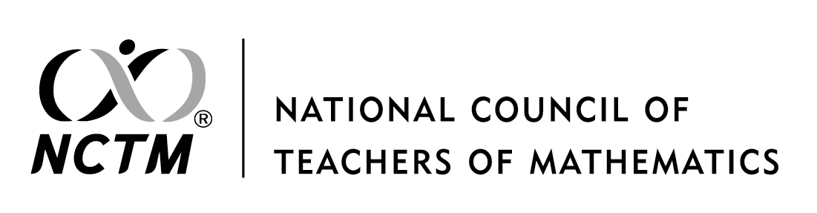

Permission Request Form

Thank you for contacting NCTM Permissions. If you represent a university, a for-profit publisher, or a for-profit training organization, please visit www.copyright.com to submit your request. For all others, please submit this form to permissions@nctm.org and allow 10 working days for your request to be processed.

Please note that the Copyright Clearance Center is authorized to handle the following requests:

Photocopying, reprinting, or republication of any NCTM copyrighted material, including Principles to Actions: Ensuring Mathematical Success for All, Curriculum Focal Points for Prekindergarten through Grade 8: A Quest for Coherence and Principles and Standards for School Mathematics (2000), for print, CD, or online; and distribution of NCTM journal articles or book chapters in electronic course packs for use in online courses on password-protected systems

Permissions will NOT be granted for material to be placed on Web pages that are open and not password protected.

Permission Request Form

Please answer all applicable questions.

Have you contacted the Copyright Clearance Center?
(Use this form only when the CCC cannot assist.)

REQUESTER INFORMATION:
Name:
Affiliation:
Email:
Phone Number:
Are you requesting permission on someone else’s behalf: YES/NO

Billing Company Name:
Billing Contact:
Billing Email:
Billing Phone Number:
Billing Mailing Address:

CHECK ALL THAT APPLY:
University (Academic Repertory License)
School District
Non-Profit Professional Development
For-Profit Professional Development
Commercial Publisher
NCTM Affiliate

ABOUT THE MATERIAL:
Title of the Requested Work:
Year of Publication:
Author(s):
Page Number(s):
Figure Number(s):
Short Description of Item:

WILL THE ITEM BE:
In print only?
How many copies?
In print and online?
If the item will be online, is the website password protected? YES/NO
Are you linking to the item or are you using a PDF of the item?
What is the website URL?

Reference #
Cite #
Terms:
Translation (Y/N):

Please email this form to permissions@nctm.org. Allow up to ten days for processing.

