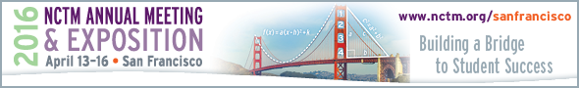

Exhibitor Sales Tax Requirements
Sales Tax Rate – 8.75%
State of California – 7.5%
San Francisco County – 1.25%

State of California Sales Tax Licensing Requirements
All vendors/businesses selling products or taking orders must apply for a Temporary Sellers Permit. Please contact the Office of the Board of Equalization at 800-400-7115 for your company’s specific licensing requirements for selling vs. only displaying.

To apply for a permit, please visit www.boe.ca.gov/info/temporary_sellers.htm.

County of San Francisco Sales Tax Licensing Requirements
All vendors/businesses selling products or taking orders in the county of San Francisco are required to complete the Business Registration Application. Please contact the County office at 415-701-2311 for your company’s specific business registration requirements for selling vs. only displaying.

To apply, please visit www.sftreasurer.org/registration.

Sales Tax Exemption
No out-of-state exemptions are accepted, you will be charged at the California stated tax rate.

The state of California will only accept in-state business/person(s) that are certified in California as Tax Exempt. You will need to obtain a copy of their tax exempt letter that is issued through the California Board of Equalization, or a copy of their tax exempt status card.

