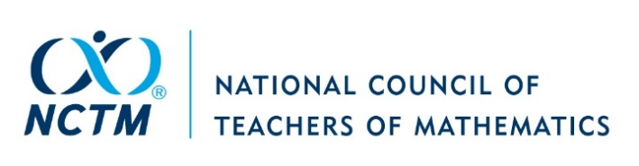
Workshop Reimbursement Form
Baltimore | November 30 – December 2, 2022

Name:
AddresS
Session #
Day
Time
Room
Capacity
Workshop speakers are expected to provide handouts and manipulatives for participants and will be reimbursed for the cost of these items up to the maximum amount calculated below. Requests are due to NCTM no later than January 2, 2023. All reimbursements will be made after the conference. One reimbursement will be processed per workshop. Refer to the meeting room capacity chart on the speaker information page to compute your maximum reimbursement amount.

The maximum reimbursement amount is $2.00 per participant up to the total seating capacity.

Items that do not qualify for reimbursement include USB drives, posters, shipping/baggage costs from the conference, books, giveaway items, door prizes, tips, and promotional materials.

Please itemize – NO request will be processed without receipts.
 | $
 | $
 | $
 | $
 | $
TOTAL | $

Signature:
NCTM Use Only:
Voucher:
Date:
Invoice Date:
Description:
Amount:
Account: 1 8102 000 060 7760
Approval/Date:
Return the completed form with receipts
by January 2, 2023, to:

National Council of Teachers of Mathematics
Attn: Regional Conferences
1906 Association Drive

Reston, VA 20191-1502
Or by Email: ConferencesDept@nctm.org

