Justification Toolkit

Making the case for support of travel, funding, and time off—especially in times of tight budgets and reduced staff—to attend any conference requires a solid understanding of the potential benefits of attending. NCTM’s conferences are not just an opportunity for you to improve your instructional practice and gain ready-to-use teaching and assessment strategies. They are also an opportunity to benefit the professional development of your colleagues, supervisor, and district. Use this toolkit to help define and clearly communicate these benefits in order to make the case to attend.

Why You Should Attend
NCTM’s conferences are a great opportunity to expand both your local and national networks, and they can help you find the information you need to prepare your PK–grade 12 students for college and career success. Classroom teachers, administrators, math coaches, supervisors, college professors, and preservice teachers can all benefit from the sessions and learning at this event.

Participants attend these conferences to—
- improve their knowledge and skills with high-quality professional development and hands-on activities;
- gain insights by connecting and sharing with like-minded educators;
- collect free activities that will keep students engaged and excited to learn; and
- learn from industry leaders and test the latest educational resources.

Expenses & Benefits
Beyond fulfilling your personal professional development goals, you can rightly claim that attending NCTM’s conferences will also enable you to bring expertise and knowledge back to your school or district. When you propose a conference for approval, be sure to focus on what you will specifically bring back to your school or district. You’ll also want to connect your responsibilities, goals, and challenges to your conference experience. To help you make a strong case for attending, here are some goals common to our attendees and the ways in which NCTM’s conferences meet these goals.

Benefits Worksheet
GOAL |  | How NCTM’s Conferences Support Your Goal
 | Gain insight into successful implementation of state-level and college- and career-ready standards | Meetings feature experts in mathematics education who will help you correlate state-level and college- and career-ready standards to your curriculum, and will give you research-based strategies to assist with implementation. A variety of sessions provide tools that connect to your everyday teaching practice in the classroom.
 | Stay on top of current (and future) trends in mathematics education | NCTM’s conferences offer concurrent sessions, workshops, and bursts to keep you ahead of the trends in mathematics education. You will gain new and effective intervention methods, refine your assessment techniques, discover the latest technologies, and acquire strategies to address the needs of each and every student—including those considered “high needs.”
 | Expand your professional network | At these events, you’ll connect with knowledgeable speakers and session leaders as well as experience exceptional peer-to-peer networking opportunities where you will learn from others and grow your network.
 | Keep your students engaged and excited about learning | Experts in mathematics education, who are breaking new ground and witnessing real success in schools across the country, present workshops and sessions to share their insights and strategies.
 | Gain fresh ideas and get inspired | Get inspired by keynote speakers and leaders in mathematics education, who will stimulate your passion for teaching mathematics.
 | Learn about new advances and technologies for the classroom | Talking with vendors can be a great way to access expert knowledge and learn about new products and educational resources. Tour a lively exhibit hall, test the latest educational resources, and collect free activities and lesson plans to bring back to the classroom.
 | Bring information back to your school or district | Session handouts are posted and available on the NCTM website after the event. You’ll be able to support the investment of time and budget dollars by setting up training sessions or sending out information on your return.

Conference Strands
All sessions, workshops, and bursts are submitted to the Program Committee before inclusion in any of the unique topic strands developed by the committee See below for strand titles and descriptions.
Empowering Students through Equitable Teaching and Learning
The focus of teaching and learning is centered on empowering each and every student as sense makers and doers of mathematics as they develop their mathematical identities and become agents of their own learning. Presentations will focus on exploring equitable teaching practices to increase the potential for engaging students in meaningful mathematical experiences.
Revolutionizing Mathematics Curriculum
Curriculum is the means to creating transformative, accessible, and authentic learning experiences for each and every student. Presentations will engage participants as critical consumers of curricula as they build connections of mathematical ideas to develop coherence across grade levels, disciplines, and contexts.
Advancing Students’ Thinking: Thoughtful and Intentional Integration of Technology
The use of tools and technology in mathematics classrooms can be a powerful way to enhance student learning when used with intent and not just for the sake of using technology. Presentations will highlight how to advance students’ accessibility to key mathematical ideas and support the development of each and every student’s conceptual understanding through the use of mathematical tools or technology.
Assessment: A Window Into Student Thinking
The focus of assessment should be capturing students’ thinking so their progress toward mathematical understanding can be gauged and instruction adjusted to support and extend learning. Presentations will focus on assessment as the vehicle to gain insights into students’ thinking, to empower students to use feedback to continue their own learning, and as a resource for planning next steps in instruction to strategically meet the needs of each and every student.
Self, Structural, and Systemic Change for Access and Equity
Access and equity in school mathematics outcomes is often conflated with equality of inputs such as providing all students the same curricular materials, the same course offerings, the same teaching methods, the same amount of instructional time, and the same school-based supports for learning. This is different, however, from ensuring that all students, regardless of background characteristics, have the same likelihood of achieving meaningful outcomes. Presentations in this strand may focus on eliminating systemic inequities and structures, developing effective accountability measures, creating access to mathematics for all students, providing strategies to humanize mathematics, and teaching for equity and social justice.
Connecting Learning Beyond the Classroom Walls
To encourage mathematical connections outside of students’ classrooms, teachers must leverage relationships with stakeholders to impact students’ families and communities. Presentations in the strand can include, but are not limited to, ways in which we broaden the mathematical community to involve families in students’ learning, methods to connect students’ home communities to their learning in school, and strategies to empower each and every student to extend their learning beyond the classroom walls to make revolutionary change.
Professionalism: Educators as Learners and Agents of Change
Empowerment of educators happens when we open our doors to professional learning. Presentations in this strand will focus on strategies for developing both individual and collaborative professional learning that will enable educators to engage in improving and enhancing mathematical knowledge and pedagogy, and understanding of students’ mathematical thinking. There will be time to reflect on the development of teachers as leaders and agents of change as well as supporting a sense of collective efficacy.

Expenses Estimate
Conference expenses are affected by a number of factors. Use the following worksheet to help you develop a cost estimate for attending your selected conference. Be prepared to compare the expenses against your benefits worksheet in order make the case for attendance.

Expense | Guideline | Cost
Conference Registration |  | $
Preconference Workshop Registration  (if applicable) | Optional fee; separate from conference registration. | $
Flight | Estimate using a travel service | $
Lodging | NCTM has negotiated discounted conference rates for hotel accommodations: room rates for the Boston conference start at $285* per night.  *Tax not included. | $
Transportation | Estimate using a travel service. Be sure to include transportation to and from the airport to the hotel. If driving, remember to include estimated parking costs and mileage reimbursement. | $
Food Per Diem |  | $
TOTAL |  | $

Registration Rates
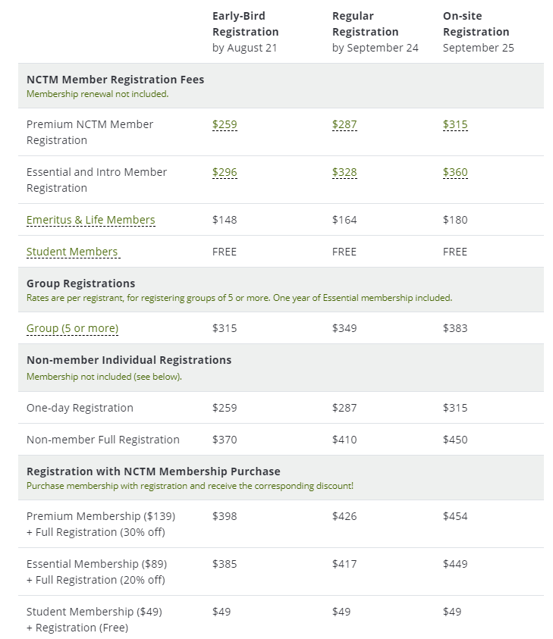

Testimonials
See what past attendees have said about NCTM in-person meetings, conferences, and events:
- “The energy, the high level of participation, the spirit, and getting together with so many people. It’s just wonderful.”
- “When I read blogs or look at different schools throughout the country and then see that they are going to be here, to be able to meet those people and connect with them in person—that really is an exciting thing.”
- “You’re exposed to so many different ideas from so many different places and things that I have never even considered. Especially when you look around and see people incorporating different things in their own individual ways it’s like, ‘Oh, I can use that too.’”
- "I don’t really have words to describe the energy in the room.”
- “It’s so awesome and great to be around so many like-minded people who want to do well for their students, and we’re all teaching the same content and we all have the same goals in mind.”
- “Having the opportunity to take an idea and go back to my classroom on Monday and be able to use it, that’s been the most valuable thing for me.”
- "Coming to the NCTM conference has opened my eyes to what it really means to teach math."
- “I will go to every workshop, every session I can, starting at 7:00 a.m. in the morning!”

Justification Letter
Dear Educator,
We have prepared the following letter to assist you in garnering support from your principal or district leader to attend an NCTM conference. Feel free to customize the document to help “make the case” for your attendance.
Dear <Colleague’s Name>,

At the NCTM 2019 Regional Conference & Exhibition in Boston, educators at all levels will be brought together to enhance their professional skills, knowledge, and careers. I would like to attend this event, which is scheduled for September 25-27, 2019, to learn best practices central to implementing college- and career-ready standards.

To meet my professional development goals, I am seeking approval for the registration fee, travel expenses to the conference, and minimal food expenses during the conference. The detailed cost breakdown is listed below.

<Insert your expense estimate numbers here>
Conference Registration ______
Preconference Workshop registration (if applicable) ______
Flight ______
Lodging ______
Transportation ______
Food per diem ______
The total estimated conference cost is ______.

By attending this conference, I will be able to select presentations (sessions, bursts, and workshops) from the following topic strands that are specific to my grade level:
- Empowering Students through Equitable Teaching and Learning
- Revolutionizing Mathematics Curriculum
- Advancing Students’ Thinking: Thoughtful and Intentional Integration of Technology
- Assessment: A Window Into Student Thinking
- Self, Structural, and Systemic Change for Access and Equity
- Connecting Learning Beyond the Classroom Walls
- Professionalism: Educators as Learners and Agents of Change

My participation in this program will complement our school’s objectives, and I plan to return with resources to share what I’ve learned with my peers and to give our students the tools they need to succeed.

Thank you in advance for your consideration.

Sincerely,

<Your Full Name>

