Justification Toolkit

Making the case for support of travel, funding, and time off—especially in times of tight budgets and reduced staff—to attend any conference requires a solid understanding of the potential benefits of attending. NCTM’s conferences are not just an opportunity for you to improve your instructional practice and gain ready-to-use teaching and assessment strategies. They are also an opportunity to benefit the professional development of your colleagues, supervisor, and district. Use this toolkit to help define and clearly communicate these benefits in order to make the case to attend.

Why You Should Attend
NCTM’s conferences are a great opportunity to expand both your local and national networks and can help you find the information you need to prepare your PK–grade 12 students for college and career success. Classroom teachers, administrators, math coaches, supervisors, college professors, and preservice teachers can all benefit from the sessions and learning at this event.

Participants attend these conferences to—
- improve their knowledge and skills with high-quality professional development and hands-on activities;
- gain insights by connecting and sharing with like-minded educators;
- collect free activities that will keep students engaged and excited to learn; and
- learn from industry leaders and test the latest educational resources.

Expenses & Benefits
Beyond fulfilling your personal professional development goals, you can rightly claim that attending NCTM’s conferences will also enable you to bring expertise and knowledge back to your school or district. When you propose a conference for approval, be sure to focus on what you will specifically bring back to your school or district. You’ll also want to connect your responsibilities, goals, and challenges to your conference experience. To help you make a strong case for attending, here are some goals common to our attendees and the ways in which NCTM’s conferences meet these goals.

Benefits Worksheet
GOAL |  | How NCTM’s Conferences Support Your Goal
 | Gain insight into successful implementation of state-level and college- and career-ready standards | Meetings feature experts in mathematics education who will help you correlate state-level, and college- and career-ready standards to your curriculum and will give you research-based strategies to assist with implementation. A variety of sessions provide tools that connect to your everyday teaching practice in the classroom.
 | Stay on top of current (and future) trends in mathematics education | NCTM’s conferences offer concurrent sessions, workshops, and bursts to keep you ahead of the trends in mathematics education. You will gain new and effective intervention methods, refine your assessment techniques, discover the latest technologies, and acquire strategies to address the needs of each and every student—including those considered “high needs.”
 | Expand your professional network | At these events, you’ll connect with knowledgeable speakers and session leaders as well as experience exceptional peer-to-peer networking opportunities where you will learn from others and grow your network.
 | Keep your students engaged and excited about learning | Experts in mathematics education, who are breaking new ground and witnessing real success in schools across the country, present workshops and sessions to share their insights and strategies.
 | Gain fresh ideas and get inspired | Get inspired by keynote speakers and leaders in mathematics education, who will stimulate your passion for teaching mathematics.
 | Learn about new advances and technologies for the classroom | Talking with vendors can be a great way to access expert knowledge and learn about new products and educational resources. Tour a lively exhibit hall, test the latest educational resources, and collect free activities and lesson plans to bring back to the classroom.
 | Bring information back to your school or district | Session handouts are posted and available on the NCTM website after the event. You’ll be able to support the investment of time and budget dollars by setting up training sessions or sending out information on your return.

Conference Strands
All sessions, workshops, and bursts are submitted to the Program Committee before inclusion in any of the unique topic strands developed by the committee. See below for strand titles and descriptions.
Assessment: Eliciting and Using Student Thinking
Effective teaching of mathematics uses evidence of student thinking to assess progress toward mathematical understanding and to adjust instruction continually to support and extend learning. Sessions in this strand will include, but are not limited to, determining mathematical goals, developing purposeful and varied ways to elicit student thinking, making sense of student thinking, asking meaningful questions to gain deeper insight into students’ understanding, and using what we learn about students’ mathematical reasoning to guide our instruction.
Building on Students’ Strengths: Practices That Challenge, Engage, Empower, and Meet the Needs of Every Student
Sessions in this strand focus on strengths-based teaching and learning practices for engaging and empowering each and every student in an inclusive classroom. Sessions attend to the design and implementation of instruction that affirms students’ identities as people and as authors of mathematics, that challenges students to solve rigorous and worthwhile mathematical tasks that are relevant to them, amplifies each and every student’s voice and mathematical ideas, supports collaborative classroom communities, or leverages mathematics as a sense-making tool for personal and social change. Sessions may specifically address Response to Intervention (RTI), Multi-Tiered Systems of Support (MTSS), inclusion, co-teaching, multilingual education, gifted programming and instruction, or other forms of differentiation and strengths-based support strategies.
Growing Professionalism and Developing Advocacy
Whether participating in your first professional learning community (PLC) or refining teaching practices to create more inclusive classrooms, we all have something to share and something to learn from each other. How do you establish and maintain professionalism in your classroom, in your interactions with families and colleagues, in your social media presence, and in your community? This strand focuses on developing your professional voice as a teacher and advocate for students and fellow teachers as you evolve throughout your educational career.
Beyond the Classroom Walls: Access, Equity, and Empowerment
The Access, Equity, and Empowerment strand will focus on policies, strategies, and practices that support or impede access to the highest quality of mathematics teaching and learning with fair and impartial opportunity. This strand will look within and beyond the classroom to investigate systemic barriers and explore ways to intentionally disrupt and dismantle them. Sessions may address policy, advocacy, attitudes, practices such as teacher or student tracking/de-tracking, and belief systems in order to empower all teachers and students as knowers and doers of mathematics.
Building Mathematical Knowledge for Teaching
Building your mathematical knowledge for teaching involves both content and pedagogical knowledge. Sessions in this strand will take a participant through the decisions a teacher makes to teach a given topic. Sessions include using and connecting mathematical representations, building procedural fluency with a foundation on conceptual understanding, developing effective questioning strategies, using technology to visualize and understand mathematical ideas, enhancing teacher content knowledge, and finding ways to articulate a mathematical concept or practice focus or a progression across grade levels.
Enhancing Mathematical Thinking Through Reading, Writing, Speaking, and Listening
Students regularly communicate in math class, but how can teachers ensure that this communication is mathematically purposeful? Sessions across this strand will explore how to encourage students to engage in expressive and receptive discourse in ways that further their mathematical thinking as well as how teachers can plan for this important aspect of instruction. Participants will explore various ways to strengthen students’ abilities to prove, justify, explain, explore, argue, and reason through the utilization of various strategies, tools, or technology.

Expenses Estimate
Conference expenses are affected by a number of factors. Use the following worksheet to help you develop a cost estimate for attending your selected conference. Be prepared to compare the expenses against your benefits worksheet in order make the case for attendance.

Expense | Guideline | Cost
Conference Registration |  | $
Preconference Workshop Registration  (if applicable) | Optional fee; separate from conference registration. | $
Flight | Estimate using a travel service | $
Lodging | NCTM has negotiated discounted conference rates for hotel accommodations: room rates for the Nashville conference start at $249* per night.  *Tax not included. | $
Transportation | Estimate using a travel service. Be sure to include transportation to and from the airport to the hotel. If driving, remember to include estimated parking costs and mileage reimbursement. | $
Food Per Diem |  | $
TOTAL |  | $

Registration Rates
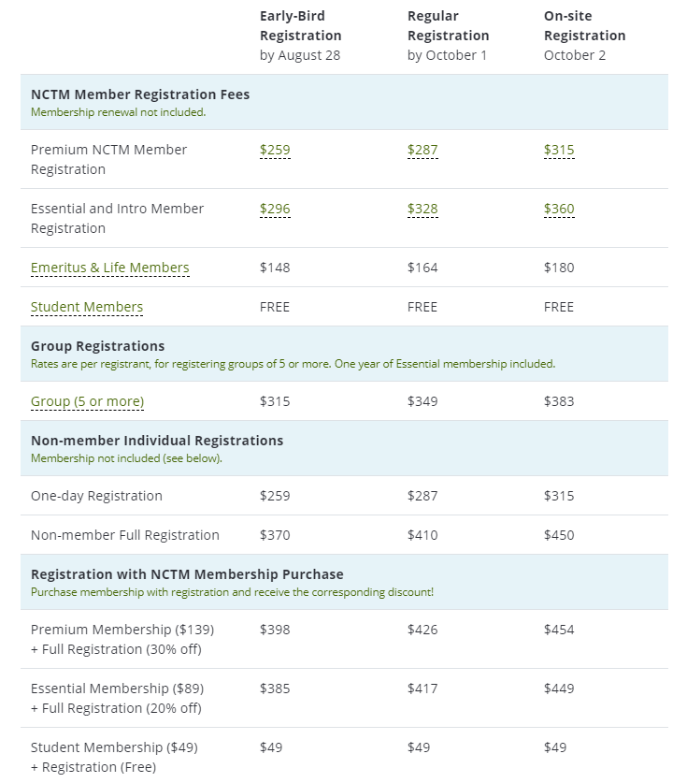

Testimonials
See what past attendees have said about NCTM in-person meetings, conferences, and events:
- “The energy, the high level of participation, the spirit, and getting together with so many people. It’s just wonderful.”
- “When I read blogs or look at different schools throughout the country and then see that they are going to be here, to be able to meet those people and connect with them in person—that really is an exciting thing.”
- “You’re exposed to so many different ideas from so many different places and things that I have never even considered. Especially when you look around and see people incorporating different things in their own individual ways it’s like, ‘Oh, I can use that too.’”
- "I don’t really have words to describe the energy in the room.”
- “It’s so awesome and great to be around so many like-minded people who want to do well for their students, and we’re all teaching the same content and we all have the same goals in mind.”
- “Having the opportunity to take an idea and go back to my classroom on Monday and be able to use it, that’s been the most valuable thing for me.”
- "Coming to the NCTM conference has opened my eyes to what it really means to teach math."
- “I will go to every workshop, every session I can, starting at 7:00 a.m. in the morning!”

Justification Letter
Dear Educator,
We have prepared the following letter to assist you in garnering support from your principal or district leader to attend an NCTM conference. Feel free to customize the document to help “make the case” for your attendance.
Dear <Colleague’s Name>,

At the NCTM 2019 Regional Conference & Exhibition in Nashville, educators at all levels will be brought together to enhance their professional skills, knowledge, and careers. I would like to attend this event, which is scheduled for October 2–4, 2019, to learn best practices central to implementing college- and career-ready standards.

To meet my professional development goals, I am seeking approval for the registration fee, travel expenses to the conference, and minimal food expenses during the conference. The detailed cost breakdown is listed below.

<Insert your expense estimate numbers here>
Conference Registration ______
Preconference Workshop registration (if applicable) ______
Flight ______
Lodging ______
Transportation ______
Food per diem ______
The total estimated conference cost is ______.

By attending this conference, I will be able to select presentations (sessions, bursts, and workshops) from the following topic strands that are specific to my grade level:
- Assessment: Eliciting and Using Student Thinking
- Building on Students’ Strengths: Practices That Challenge, Engage, Empower, and Meet the Needs
of Every Student
- Growing Professionalism and Developing Advocacy
- Beyond the Classroom Walls: Access, Equity, and Empowerment
- Building Mathematical Knowledge for Teaching
- Enhancing Mathematical Thinking Through Reading, Writing, Speaking, and Listening

My participation in this program will complement our school’s objectives, and I plan to return with resources to share what I’ve learned with my peers and to give our students the tools they need to succeed.

Thank you in advance for your consideration.

Sincerely,

<Your Full Name>

