Justification Toolkit

Making the case for support of travel, funding, and time off—especially in times of tight budgets and reduced staff—to attend any conference requires a solid understanding of the potential benefits of attending. NCTM’s conferences are not just an opportunity for you to improve your instructional practice and gain ready-to-use teaching and assessment strategies. They are also an opportunity to benefit the professional development of your colleagues, supervisor, and district. Use this toolkit to help define and clearly communicate these benefits in order to make the case to attend.

Why You Should Attend
NCTM’s conferences are a great opportunity to expand both your local and national networks, and they can help you find the information you need to prepare your PK–grade 12 students for college and career success. Classroom teachers, administrators, math coaches, supervisors, college professors, and preservice teachers can all benefit from the sessions and learning at this event.

Participants attend these conferences to—
- improve their knowledge and skills with high-quality professional development and hands-on activities;
- gain insights by connecting and sharing with like-minded educators;
- collect free activities that will keep students engaged and excited to learn; and
- learn from industry leaders and test the latest educational resources.

Expenses & Benefits
Beyond fulfilling your personal professional development goals, you can rightly claim that attending NCTM’s conferences will also enable you to bring expertise and knowledge back to your school or district. When you propose a conference for approval, be sure to focus on what you will specifically bring back to your school or district. You’ll also want to connect your responsibilities, goals, and challenges to your conference experience. To help you make a strong case for attending, here are some goals common to our attendees and the ways in which NCTM’s conferences meet these goals.

Benefits Worksheet
GOAL |  | How NCTM’s Conferences Support Your Goal
 | Gain insight into successful implementation of state-level and college- and career-ready standards | Meetings feature experts in mathematics education who will help you correlate state-level, and college- and career-ready standards to your curriculum, and will give you research-based strategies to assist with implementation. A variety of sessions provide tools that connect to your everyday teaching practice in the classroom.
 | Stay on top of current (and future) trends in mathematics education | NCTM’s conferences offer concurrent sessions, workshops, and bursts to keep you ahead of the trends in mathematics education. You will gain new and effective intervention methods, refine your assessment techniques, discover the latest technologies, and acquire strategies to address the needs of each and every student—including those considered “high needs.”
 | Expand your professional network | At these events, you’ll connect with knowledgeable speakers and session leaders as well as experience exceptional peer-to-peer networking opportunities where you will learn from others and grow your network.
 | Keep your students engaged and excited about learning | Experts in mathematics education, who are breaking new ground and witnessing real success in schools across the country, present workshops and sessions to share their insights and strategies.
 | Gain fresh ideas and get inspired | Get inspired by keynote speakers and leaders in mathematics education, who will stimulate your passion for teaching mathematics.
 | Learn about new advances and technologies for the classroom | Talking with vendors can be a great way to access expert knowledge and learn about new products and educational resources. Tour a lively exhibit hall, test the latest educational resources, and collect free activities and lesson plans to bring back to the classroom.
 | Bring information back to your school or district | Session handouts are posted and available on the NCTM website after the event. You’ll be able to support the investment of time and budget dollars by setting up training sessions or sending out information on your return.

Conference Strands
All sessions, workshops, and bursts are submitted to the Program Committee before inclusion in any of the unique topic strands developed by the committee. See below for strand titles and descriptions.
Professionalism Redefined: Teacher Learners & Teacher Leaders
As teachers we more frequently talk about what we can do to help our students, but very infrequently do we talk about the struggles and realities that teachers deal with and what it takes to survive and thrive as an educator. Presentations in this strand will focus on re-energizing the concept of being a professional by helping teachers find a community in which they can learn to recognize the elements of quality practice. Additionally, this strand will focus on promoting teachers as leaders and advocates for themselves and their profession.
Access, Equity, and Empowerment: Teaching Brilliance
Seeing students as brilliant requires educators to gain a deep understanding of their resources, lived experiences, and knowledge. Presentations will investigate the ways that educators consider the impact of privilege in the mathematics classroom and share strategies for disrupting that privilege and focusing on the brilliance of each and every student.
Tools for Teaching and Discourse: More Than Talk
What are best practices for facilitating mathematical discourse? What tools can teachers leverage to deepen the mathematical discourse in their classrooms? What tasks support such discourse? Presentations in this strand will focus on current and innovative practices that 1) incorporate the strategic use of mathematical discourse, 2) enhance students’ learning and understanding through the use of mathematical tools, or 3) encourage all students to participate fully in their learning community.
Leveraging Assets: Learning to “Shop” in Students’ Stores
Students enter mathematics classrooms with diverse experiences and knowledge that create funds, or stores, of opportunity. With a focus on how to leverage students’ stores and position all students as knowers and doers of mathematics, sessions will address eliciting and using student thinking for understanding, acknowledging students as positive resources in mathematics learning, eliminating deficit thinking that dehumanizes mathematics and replacing it with a rehumanizing approach, and celebrating the dimensions of student diversity.
Differentiation: Increasing Opportunity for All Students
What are the possibilities when all students can access the content? How can we as educators help to ensure that happens? In order to afford each and every student access, we must increase our skills at differentiating both the content and the environment. Sessions within this strand will afford educators the opportunity to explore learning spaces beyond the traditional classroom, innovative ways to provide accommodation and intervention, how to be flexible with time, and methods to shape the learning environment to match the learner.
Mathematics: Continually Learning the Content We Teach
What are the important ideas of mathematics? How do these topics connect to each other? How are they best understood by novice and more advanced learners? In order to be constantly assessing our students and creating environments where they can best discover the beauty and elegance of mathematics, we can continue to learn about the subject we teach. Presentations in this strand will provide opportunities for teachers to develop a deeper understanding of mathematics.

Expenses Estimate
Conference expenses are affected by a number of factors. Use the following worksheet to help you develop a cost estimate for attending your selected conference. Be prepared to compare the expenses against your benefits worksheet in order make the case for attendance.

Expense | Guideline | Cost
Conference Registration |  | $
Preconference Workshop Registration  (if applicable) | Optional fee; separate from conference registration. | $
Flight | Estimate using a travel service | $
Lodging | NCTM has negotiated discounted conference rates for hotel accommodations: room rates for the Salt Lake City conference start at $195* per night.  *Tax not included. | $
Transportation | Estimate using a travel service. Be sure to include transportation to and from the airport to the hotel. If driving, remember to include estimated parking costs and mileage reimbursement. | $
Food Per Diem |  | $
TOTAL |  | $

Registration Rates
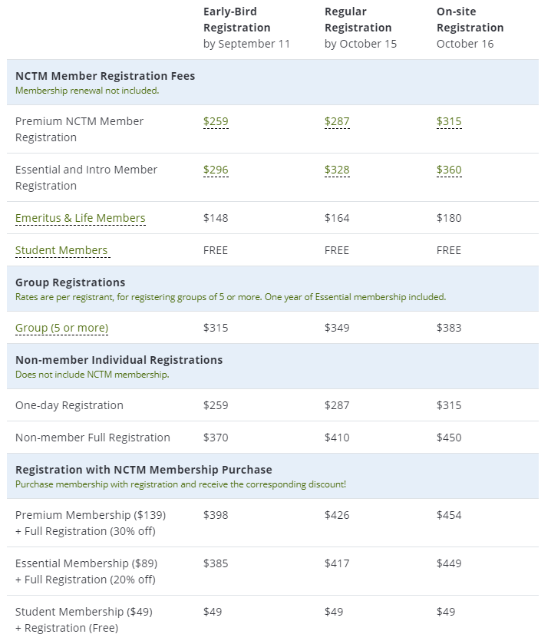

Testimonials
See what past attendees have said about NCTM in-person meetings, conferences, and events:
- “The energy, the high level of participation, the spirit, and getting together with so many people. It’s just wonderful.”
- “When I read blogs or look at different schools throughout the country and then see that they are going to be here, to be able to meet those people and connect with them in person—that really is an exciting thing.”
- “You’re exposed to so many different ideas from so many different places and things that I have never even considered. Especially when you look around and see people incorporating different things in their own individual ways it’s like, ‘Oh, I can use that too.’”
- "I don’t really have words to describe the energy in the room.”
- “It’s so awesome and great to be around so many like-minded people who want to do well for their students, and we’re all teaching the same content and we all have the same goals in mind.”
- “Having the opportunity to take an idea and go back to my classroom on Monday and be able to use it, that’s been the most valuable thing for me.”
- "Coming to the NCTM conference has opened my eyes to what it really means to teach math."
- “I will go to every workshop, every session I can, starting at 7:00 a.m. in the morning!”

Justification Letter
Dear Educator,
We have prepared the following letter to assist you in garnering support from your principal or district leader to attend an NCTM conference. Feel free to customize the document to help “make the case” for your attendance.
Dear <Colleague’s Name>,

At the NCTM 2019 Regional Conference & Exhibition in Salt Lake City, educators at all levels will be brought together to enhance their professional skills, knowledge, and careers. I would like to attend this event, which is scheduled for October 16–18, 2019, to learn best practices central to implementing college- and career-ready standards.

To meet my professional development goals, I am seeking approval for the registration fee, travel expenses to the conference, and minimal food expenses during the conference. The detailed cost breakdown is listed below.

<Insert your expense estimate numbers here>
Conference Registration ______
Preconference Workshop registration (if applicable) ______
Flight ______
Lodging ______
Transportation ______
Food per diem ______
The total estimated conference cost is ______.

By attending this conference, I will be able to select presentations (sessions, bursts, and workshops) from the following topic strands that are specific to my grade level:
- Professionalism Redefined: Teacher Learners & Teacher Leaders
- Access, Equity, and Empowerment: Teaching Brilliance
- Tools for Teaching and Discourse: More Than Talk
- Leveraging Assets: Learning to “Shop” in Students’ Stores
- Differentiation: Increasing Opportunity for All Students
- Mathematics: Continually Learning the Content We Teach

My participation in this program will complement our school’s objectives, and I plan to return with resources to share what I’ve learned with my peers and to give our students the tools they need to succeed.

Thank you in advance for your consideration.

Sincerely,

<Your Full Name>

