Reasoning Talk Planning Examples

Heavy Packs
7.SP.B.3
Informally assess the degree of visual overlap of two numerical data distributions with similar variabilities, measuring the difference between the centers by expressing it as a multiple of a measure of variability. For example, the mean height of players on the basketball team is 10 cm greater than the mean height of players on the soccer team, about twice the variability (mean absolute deviation) on either team; on a dot plot, the separation between the two distributions of heights is noticeable.

Compare the weight of the backpacks for the students in these three grades.
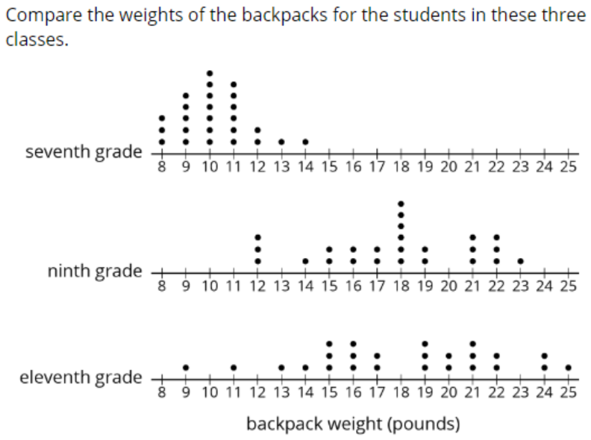

Prompt
If you wanted to compare the means of these three dot plots, what do you need to pay attention to?

Anticipating
Finding the total of each graph (thinking procedurally about Sum X1—Xn/n)
Spread or distribution for 9th and 11th is similar and thus the mean will be similar
7th data is grouped together on low side of the scale and thus has a lower mean weight

Key maths ideas
Spread/distribution
Variability
Mean as sharing and/or balancing

The Mover
7.EE.B.4.b
Solve word problems leading to inequalities of the form px + q > r or px + q < r, where p, q, and r are specific rational numbers. Graph the solution set of the inequality and interpret it in the context of the problem. For example: As a salesperson, you are paid $50 per week plus $3 per sale. This week you want your pay to be at least $100. Write an inequality for the number of sales you need to make, and describe the solutions

Prompt
A mover is loading an elevator with boxes that all weigh the same. The mover weighs 185 pounds. The elevator can carry at most 2000 pounds. If the mover asked, “How many boxes can I load on this elevator at a time?”

1. What information are you going to use first to solve this problem?
2. How do you plan to use this information?
3. Why does this information matter?
4. What mathematical questions do you want to ask the mover?

5. What is the most important information needed to answer the mover?

Anticipating/Misconceptions
Box weight is unknown
Disregard the weight of the mover
Think a maximum number of boxes must be found

Key Mathematics
This scenario represents an inequality and not a linear relationship
Sum of the weight of the boxes and the mover cannot exceed 2000 pounds
Box weight is needed to determine the number of boxes

Shaded Shapes
7.G.B.4 Know the formulas for the area and circumference of a circle and use them to solve problems; give an informal derivation of the relationship between the circumference and area of a circle.
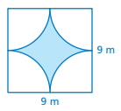
First image shown Second image shown

*modified from Big Ideas

Prompt
1. What mathematical questions can you ask based on this image?
2. What information do you need to answer your question?

Anticipating/Misconceptions
What is the ratio/percent of the blue/white?
What is the area of the blue/white region?
What is the area of the square?
How do the blue and the white compare?
How big is the perimeter?
How many circles are in the shape?

Key Maths Ideas
The radius is needed to determine the area of a circle
Area of square
Ratio of blue to white regions
Difference between square and circles to find area of blue region

Other Possibilities
What information would be helpful in finding the area of the shaded region?
How does the shaded region compare to the non-shaded region?
What information can you get from this picture?
How? Show me where you see that.

