Sample Reasoning Talk Questions & Prompts

1. Calculating Cuts
A Carpenter cuts an 8-ft board into two pieces, one piece is three times as long as the other. What is the length of each piece? Write a system of equations that describes this situation and solve.

1. What mathematics will be most helpful and why?

2. Perimeter Relationships
The length of a rectangle is 2 cm more than four times the width. The perimeter of the rectangle is 84cm. Find the dimensions of the rectangle.

1. What do you know about this relationship?
2. How do you plan to use this information?

3. Heavy Packs (7.SP.B.3)
Compare the weight of the backpacks for the students in these three grades.

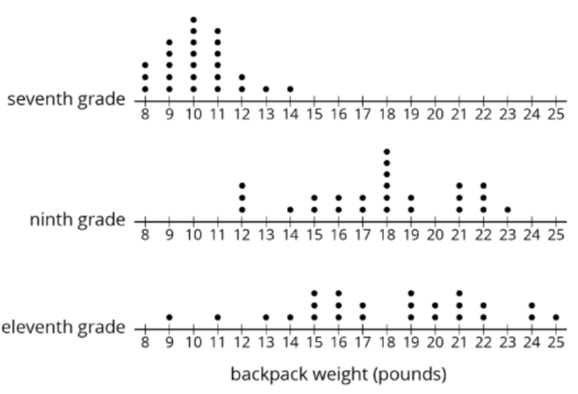
1. If you wanted to compare the means of these three dot plots, what do you need to pay attention to?

4. The Dolphin (7.G.1)
A dolphin in an aquarium is 12 feet long. A scale model of the dolphin is 3 inches long.

1. What do you notice? What do you wonder?
2. How would your thinking change if the scale model was 3 ½ inches long?

5. Mowing Madness
Kian and Leif are each responsible for mowing half of their back yard. The yard is rectangular with dimensions of 75 feet 6 inches long and 90 feet 4 inches wide. Kian starts mowing at a
corner, gradually working his way toward the middle by mowing concentric bands around the outside edges. The mower cuts a two foot 6 inch wide path, so at what point should Kian stop and Leif take over to finish mowing the yard?

1. Before you begin, what information do you feel is the most important to attend to and why?

6. The Mover (7.EE.B.4.B)
A mover is loading an elevator with boxes that all weigh the same. The mover weighs 185 pounds. The elevator can carry at most 2000 pounds. If the mover asked, “How many boxes can I load on this elevator at a time?”

1. What information are you going to use first to solve this problem?
2. How do you plan to use this information?
Other Possibilities
3. Why does this information matter?
What mathematical questions do you want to ask the mover?
What is the most important information needed to answer the mover?

8. The Iguana

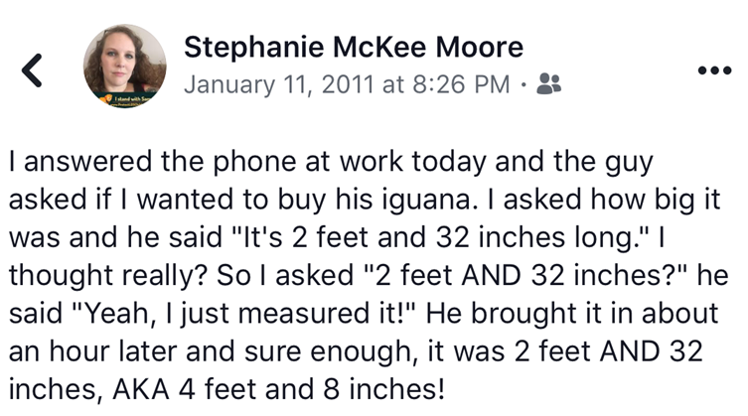
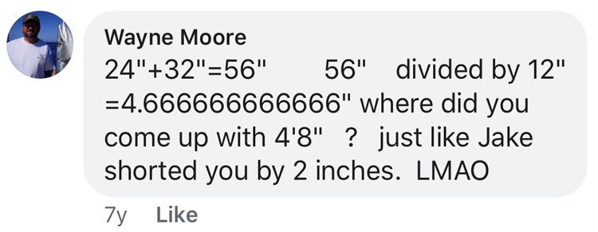
What matters with Wayne’s thinking?

9. Car Care

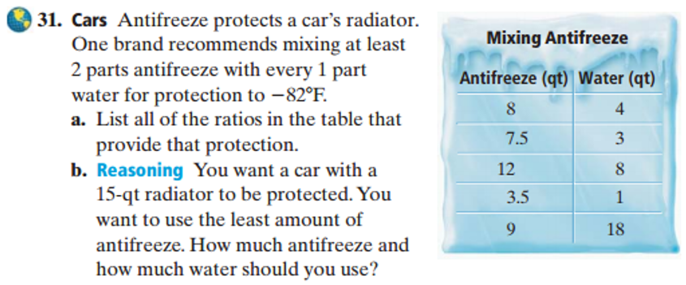

1. What information is not important? Why?
2. How might you go about solving this problem?
3. Why does that make sense?

10. Shaded Shapes (7.G.B.4)
First Image shown

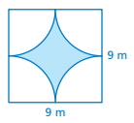
Second image shown
*modified from Big Ideas

1. What mathematical questions can you ask based on this image?
2. What information do you need to answer your question?
11. The Blueprint

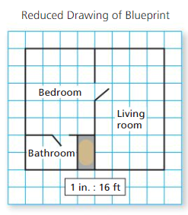
1. What might you be asked to find?
2. How would you keep track of the information needed?

